LIBRARY SEARCH SYSTEM

***DR\ Sally Saad***

***T.A\ Eman Mahmoud***

***Team Members:***

***1\EMAN OSSAMA MOHAMED***

***2\HABIBA KHALED MOHAMED***

***3\DINA ABDALLAH SAID***

***4\KHALED GAMAL SHESHTAWY***

***5\HOSSAM SHAABAN***

***This program when you search about a word 🡪 will show you the number of books found inside and will show them descending order according to the number of repetitions of this word within the book.***

***Simple run :***

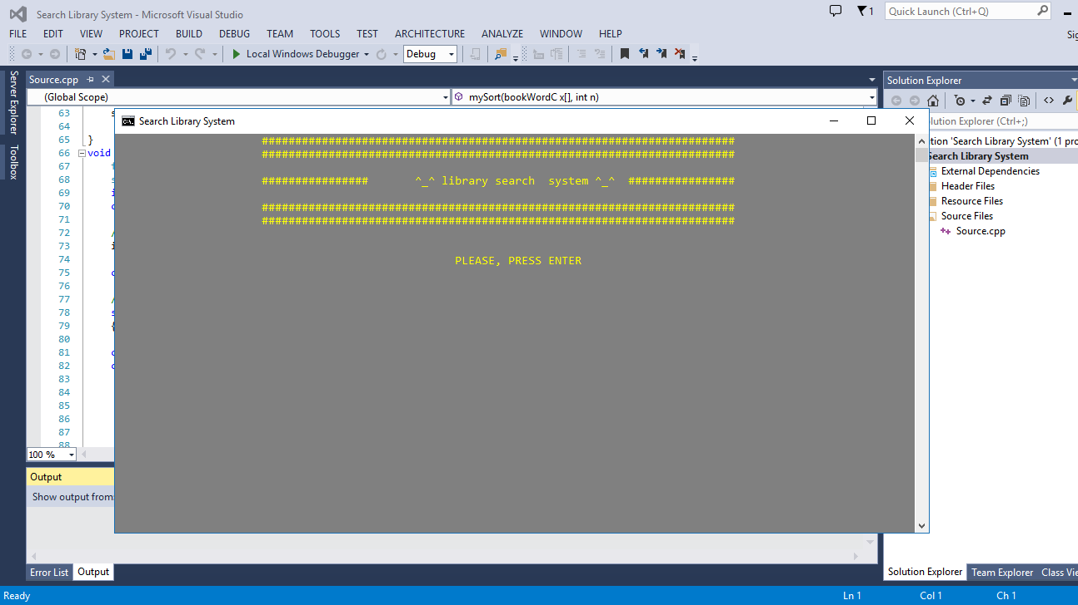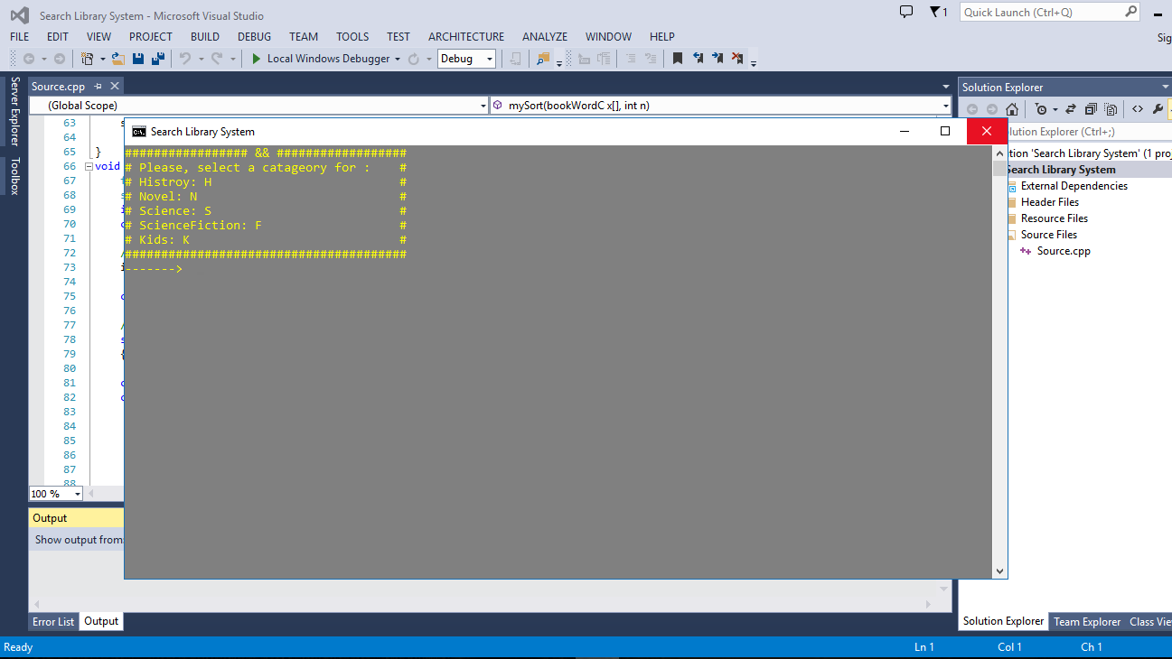

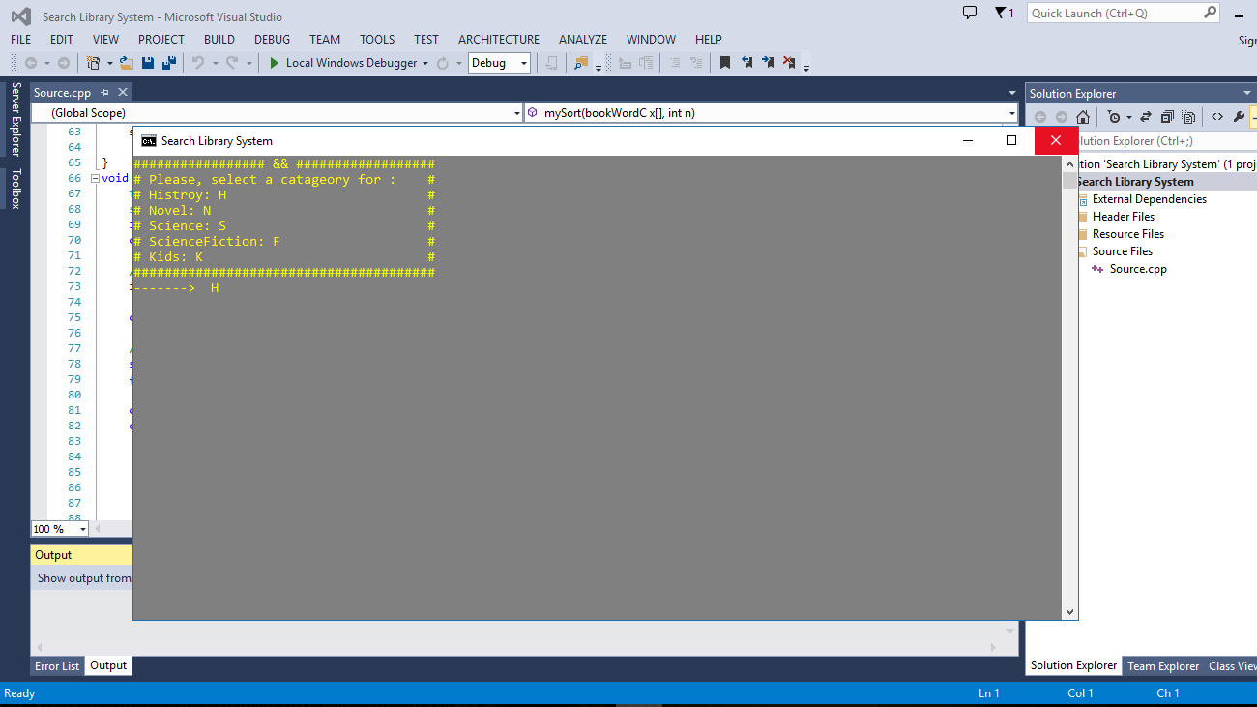

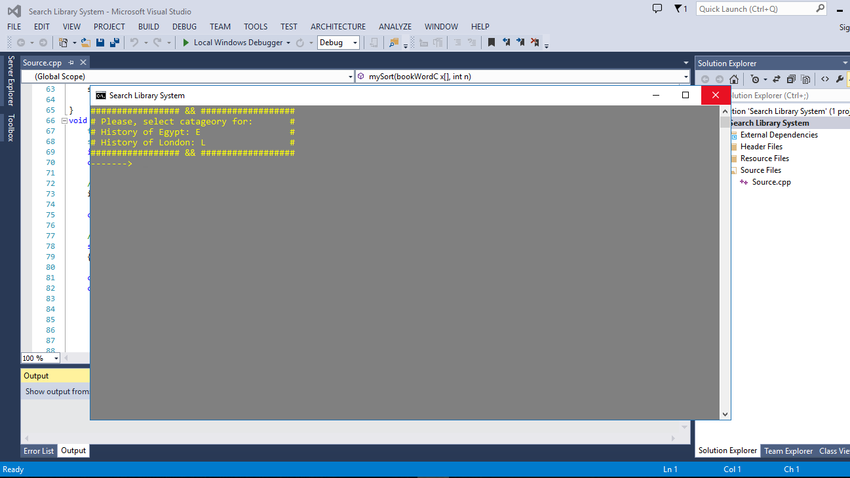

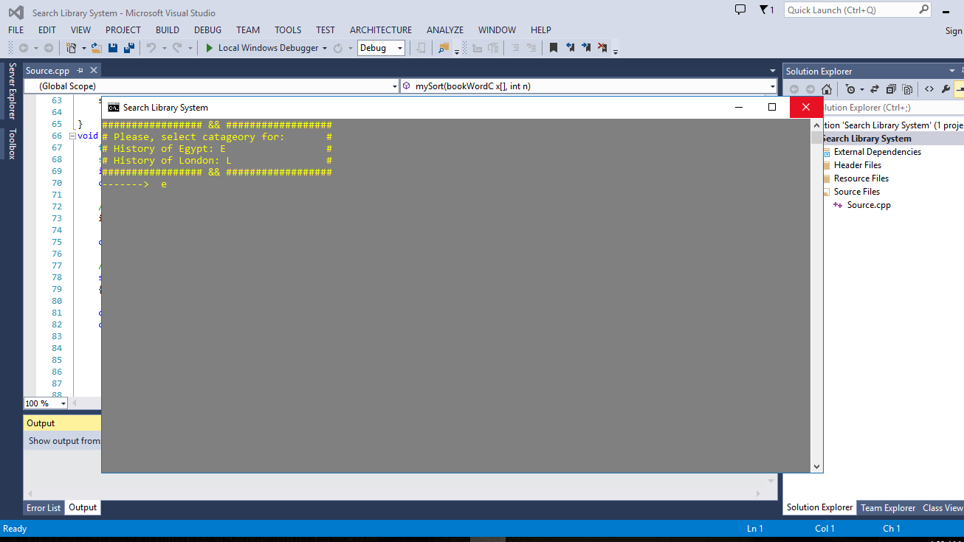

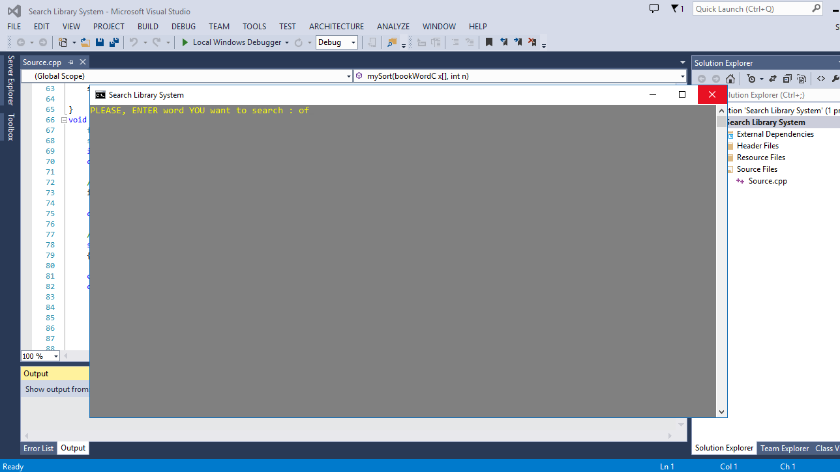

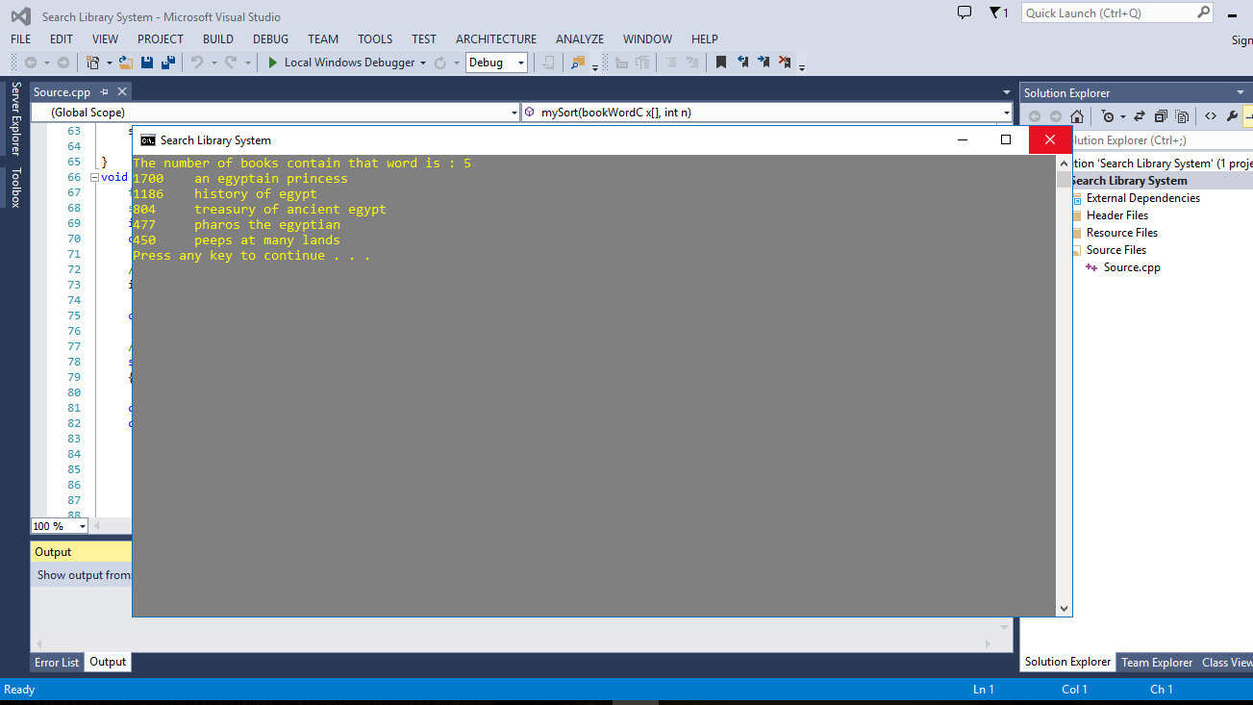

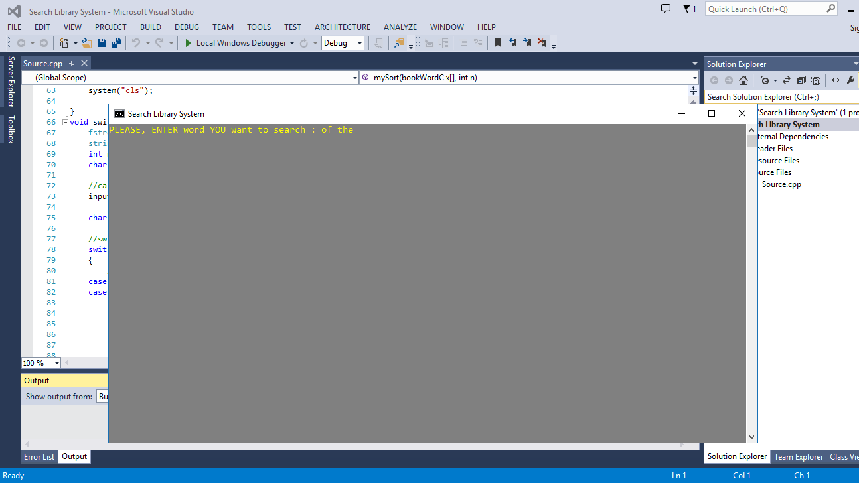

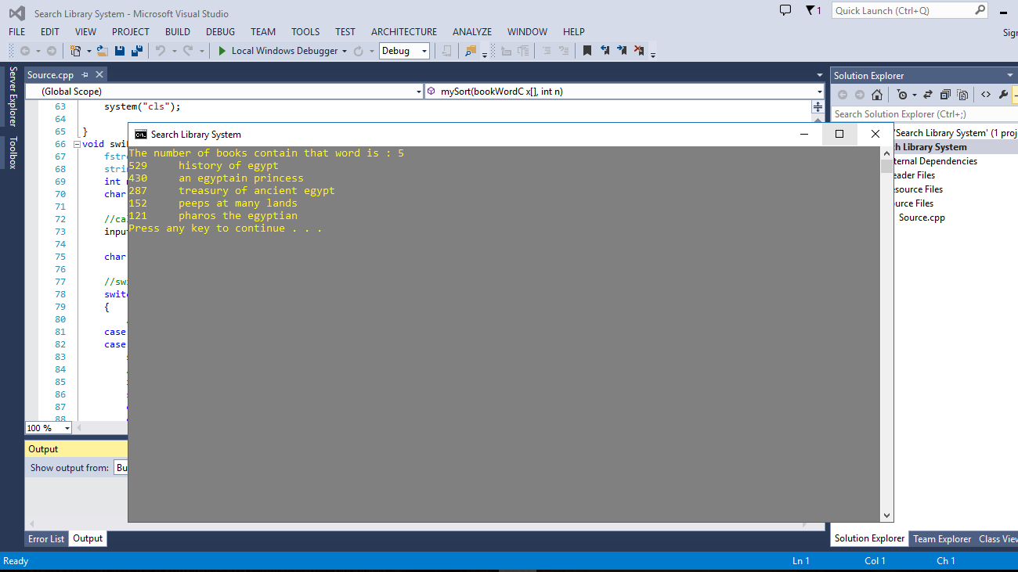***Why is research important in books?***

***The search enables the user to verify the validity of the information he owns and to increase his / her culture and the extent to which the books relate to the domain to which he is reporting.***

***What is the library?***

***Is to possess knowledge about the past and present and provide the user with the appropriate knowledge and documented.***

***This library has five sections : History , Novel , Science , Science fiction , Kids.***

***In order to facilitate the user to verify the data easily and get the information in a short time.***

***Other useful use:***

***We can use it in competitions to determine who could use a specific word most.***